***OPERATOR OWNER’S MANUAL***

***Direct Drive Door Operator with APEX Pro***

Section – 3 Introduction 5

About This Manual 5

About Your Warranty 5

Technical Support Department 5

About Your Serial Number 5

How to Use This Manual 6

Safety Check List 6

Required Tools and Equipment 7

Labor and Site Requirements 7

Electrical Responsibilities 7

Freight Receiving 8

If the installation is stopped due to damage 8

Returning damaged components 8

Verify that all components have arrived 8

Section – 4 System Overview 9

Drive Unit Specifications 10

Control Panel Specifications 10

Control Panel Amperage Rating Table 10

Drive Unit 11

Apex Pro Smart Controller 11

Apex Pro SmartController 12

About the Control Panel 12

Navigating the Menu: Using the Control Screen 12

Control Buttons Located on the Front of the Control Panel enclosure and Navigation Arrow in the inside PCB board. 12

Using the LCD Screen 13

Using the Menu Screen 14

Using the Options Screen 15

Using the Modify Settings Screen 16

Status LEDs 17

System Reset (Manual) 18

Firmware update 18

Section – 5 Installation 19

Mounting the Motor Operator 19

Mounting the Control Panel 19

Section – 6 Quick Start Guide 20

Introduction 20

Control Panel 21

Control Panel Structure 21

Typical Motor Mounted VFD Power Connections 21

Connect the Motor Power 21

Drive and Tension Side Sensor Cables 22

Connect the Drive and Tension Side Sensor Cables, Photo Eyes, and Light Curtains 22

Power Supply 23

Connect Incoming Power 23

Final Steps 24

Section – 7 Connections for Optional Control Accessories 25

About the Wireless Sensing Edge 25

About External OPEN/CLOSE/STOP Stations 26

About the Motion Detector 27

About Radio Controls / Digital Keyless Entry / Open/Close Devices 28

Radio Receivers 28

Extended Standard Module 30

Section – 8 System Start-Up and Operation 31

Extended Optional Modules 31

Commissioning (Program Mode) 32

Time Setting and Basic Setting Items 35

Advanced Setting items in More Settings 44

Section – 9 System Status Messages 47

Section – 10 Schematics 49

Plug & Play Wiring Details 49

Motor to Apex Pro. Panel Connections 49

Pre-Wired Motor Mounted VFD Apex Pro Components 49

Drive Side Sensor Package Cables Connections 50

Y-Connector Tension Side Sensor Package Cable Connections 50

Section – 11 Maintenance 51

Maintenance Schedule 51

Motor Operator Maintenance 51

Section – 12 Troubleshooting 52

Troubleshooting Table 52

Section – 13 Parts List 55

Parts Ordering Information 55

How to Order Parts 55

APEX Pro Parts List 56

Cabling Parts, Sensors, Junction Boxes 56

Serial Numbers 56

Substitute Parts 56

Warranty and Returned Parts Policy 56

Warranty Parts 56

**List of Figures**

Figure 4.1 Drive Unit 11

Figure 4.2. Apex SmartController 11

Figure 4.3. Control Buttons (Left) and Navigation Arrow Buttons (Right) 12

Figure 4.4. Start Screen: Program Mode 13

Figure 4.5. Normal Mode 13

Figure 4.6. Override Mode Dip Switch 14

Figure 4.7. Menu Screen 14

Figure 4.8. Options Screen 15

Figure 4.9. Modify Settings Screen 16

Figure 7.1. Wireless Sensing Edge. 25

Figure 7.2. External Control Stations. 26

Figure 7.3. Motion Sensor 27

Figure 7.4. Single Channel Radio Receiver 28

Figure 7.5. Three Channel Radio Receive 29

Figure 7.6. Standard Extended Module 30

Figure 8.1. Optional Autolock Module 31

Figure 8.2. Optional Power Relay Module 31

Figure 8.3. Disable Button Functionality Dip Switch 34

Figure 10.1. VFD Terminal Connections 49

Figure 10.2. Drive Side Sensor Package Cables Connections 50

Figure 10.3. Y-Connector Cable Connections 50

Figure 13.1. Exploded Diagram of Operator 55

**List of Tables**

Table 3.1. Potential Hazards and Preventative Measures 6

Table 4.1. Specifications 9

Table 4.2. Control Panel Amperage Rating Table 10

Table 4.3. Drive Unit 11

Table 4.4. System Inputs 17

Table 4.5. System IOs 18

Table 8.1. Main Menu Items 44

Table 8.2. Advanced Menu Items 46

Table 9.1. System Status Messages 48

Table 12.1. Troubleshooting 54

Table 13.1. Operator Bill of Materials 55

# Introduction

## About This Manual

This manual is intended for the Direct Drive Motor with Apex Pro. SmartController only. Installation and operation information specific to your door is detailed in the Installation and Owner’s manuals that were shipped with the door.

## About Your Warranty

The Direct Drive Motor with Apex Pro. SmartController has been designed for ease of installation and operation. While every effort has been made to simplify and speed up installation, it is important that you follow the procedures outlined in this manual to ensure proper installation and functionality. Failure to follow these procedures, or steps as outlined, will automatically void the warranty. Do not alter the working parts, assemblies, or specifications as written; doing so, without prior authorization by CornellCookson, will void the warranty.

IMPORTANT:  
Read and understand the instructions in this manual BEFORE you attempt to install, operate, or perform maintenance on this motor operator and control system.

If you have any questions, locate and refer to the Apex Serial # and Item # of the door that you’re working on and contact your CornellCookson representative or call the CornellCookson Technical Support Department.

The wiring connections and schematics in this manual should cover most basic access control and entrapment equipment connections. Please refer to this manual and the wiring details that are shipped with these components.

### 

**The** Technical Support Department **at may be reached by calling (855)-594-4969.**

## About Your Serial Number

Your SERIAL NUMBER information can be found attached to the cover of the Apex Pro. Smart Controller cover.

IMPORTANT:  
When installing multiple units, verify that the serial number in the control panel matches the one on the door assembly as the control panel may have been customized for a specific door. Additionally, match the Door serial # with the markings on the motor box to match the proper motor to the door prior to installation.

## How to Use This Manual

Throughout this manual, the following key words are used to alert the reader of potentially hazardous situations, or situations where additional information to successfully perform the procedure is presented:

WARNING.JPG

**WARNING IS USED TO INDICATE THE POTENTIAL FOR PERSONAL INJURY, IF THE PROCEDURE IS NOT PERFORMED AS DESCRIBED.**

CAUTION.JPG

***CAUTION is used to indicate the potential for damage to the product or property damage, if the procedure is not followed as described.***

**IMPORTANT:**

IMPORTANT is used to relay information CRITICAL to the successful completion of the procedure.

NOTE: NOTE is used to provide additional information to aid in the performance of the procedure or operation of the door, but not necessarily safety related.

## Safety Check List

Rolling doors are large, movable objects. They move with the help of electric motors or manual operators (chain, crank, push up, etc), and most have springs under high tension. These items and their components can cause injury. In order to avoid injury to yourself and others, please follow the instructions in this manual.

**Review the potential hazards and preventative measures listed below:**

|  |  |  |
| --- | --- | --- |
| **Potential Hazard** | | **Preventative Measure** |
| hit from above.JPG | **Pinned or crushed by closing door.** | * Keep yourself and others clear of opening while door is in motion. * Do not allow children to play near or operate door. * Do not operate if door becomes jammed or broken. |
| shock.JPG | **http://www.mysafetysign.com/SAFE/images/ansi_warning.gifElectrical shock.** | * Make sure electrical operator is properly grounded. * Turn off source power completely prior to servicing the motor. * Make sure wires are clear of any moving or potentially moving parts. * Avoid pinching wires when installing the motor cover. |
| chain pinch.JPG | **http://www.mysafetysign.com/SAFE/images/ansi_warning.gif**  **Pinched by moving components.** | * Make sure the motor is turned off and unplugged before working with moving parts such as roller chain and sprockets, drop-out mechanisms, adjusting wheels, etc. * Locate the possible pinch-points of the unit (Drive chain, coil area, bottom bar, etc.) Do not operate the door while someone is near these areas. |

Table 3.1. Potential Hazards and Preventative Measures

* **Check the following during installation and before leaving the job site:**
  1. If the unit has tension springs, be sure the proper amount of tension is applied to the torsion springs, in order to properly counterbalance the weight of the curtain.
  2. Securely fasten the tension adjusting wheel in place with the appropriate hardware provided.
  3. Check that the keys and/or cotter pins have been set in place and fit properly at all sprockets or gears.
  4. Check that the setscrews in each sprocket or gear (one over the key and one offset from the key) have been tightened properly.
  5. Check all fasteners holding the unit to the building structures.
  6. Check all fasteners used to assemble the components of the unit together.
  7. Instruct owner or representative in the proper method of operating the door.

## Required Tools and Equipment

Carpenter’s level or Water level Hammer drill and masonry drill bit sized for wall anchors (to install anchor hardware in concrete). Assorted hand tools, such as Screw Drivers, Hand Saw, Wire Striper, ¾ inch rigid conduit, ¾” fittings, reducing washers, electrical connectors, junction boxes, Circuit breaker and fuses, and anything else required by code, etc.

## Labor and Site Requirements

The advanced control system and motor supplied with your door has been partially pre-wired at the factory to make the installation quick and easy, while remaining adaptable to the varying conditions of installation sites.

Section – 6 covers the connections of the motor to control panel, and basic sensor package. Other possible sensor connections are also covered in Section – 7 of this manual. An electrician should mount and wire the local disconnect and terminate power to the Apex Pro. SmartController. (See “Electrician’s Responsibilities” below.) Depending on your jurisdiction, an electrician may be required for all electrical connections, or the installing dealer may be able to complete the connection of motor to control panel, and sensors.

IMPORTANT: All electrical work must be performed in accordance with local and state building codes.

NOTE: Do not allow any traffic to pass through the door opening during the installation procedure.

## Electrical Responsibilities

NOTE: A door-specific electrical schematic is located inside the control panel.

Electrician’s responsibilities include:

1. Furnish and install fused disconnect(s). This is not included in the door or Controller package, it is required and should be installed by the electrician.
2. Install Advanced Control System panel.
3. Install all necessary conduits.

**NOTE:** High- and low-voltage cables must be routed in separate metallic or metal lined flexible conduit.

1. Run electrical power lines to the fused disconnect.
2. Run power lines from disconnect to motor VFD.
3. Run control lines from control panel to motor VFD assembly.
4. Install conduit as necessary to route wires from sensors and activation devices to the control panel when/if used.
5. All cables must be cut to length. No excess of high or low-voltage cables should be present inside the control panel. Care should be taken to minimize excess cabling and wires inside the control panel. High and low voltage wiring should be segregated and kept separate to avoid feedback and EMF interference whenever possible.

## Freight Receiving

**IMPORTANT:**  
 Upon delivery, check the condition of all components for damage.

If damage occurred in transit, do not proceed with the installation without authorization.

CAUTION.JPG  
  
***If the installation proceeds, neither the carrier nor the manufacturer will assume responsibility for replacing the damaged material.***

If the installation is stopped due to damage**, do the following:**

1. Take pictures of the damage.
2. Do not move material from point of delivery to other premises once the damaged components are discovered.
3. Do not unpack, if the damage is visible prior to removing packaging, until an inspection is made.
4. If the damage is found while removing contents from packaging, the packaging material must be saved until inspection is made.
5. Container and packaging should be retained by consignee until inspection is made.
6. Have components inspected by carrier’s representative within 15 days from date of delivery.
7. Consignee must obtain a copy of the Inspection Report.

Returning damaged components:

* 1. Obtain permission from carrier to return.
  2. Route the return shipment via the identical carrier(s) involved in the original shipment.
  3. Notify the manufacturer when shipment is returned to manufacture plant.

Verify that all components have arrived.

Look for the following:

1. Motor with flexible conduit attached;
2. Control Panel with VFD, cables installed and flexible conduit attached;
3. Venting Plug with apply tool;
4. Encoder extension cable;
5. User manual

**If the delivery is incomplete**:

* 1. Make note on delivery receipt.
  2. Note should be verified by driver’s signature.
  3. Notify carrier and manufacturer.

# System Overview

The motor and advanced control system shipped with your door are specifically designed for reliability and longevity when used as a rolling steel door operator. The hollow shaft motor unit features a direct drive gear reducer, emergency hand chain and a high efficiency motor and solenoid brake.   
  
The advanced control system is a solid state, microprocessor-based control system. It represents the latest in rolling steel door drive technology and had been configured and set-up exclusively for your door. It includes soft stop and soft start technology. Operating parameters, system status messages, and menu items can be accessed through the [↑], [↓], [←], [→] and the OK buttons on the control face.

CAUTION.JPG

**The advanced control system is configured at the factory for the voltage specified in your order.   
It is available in voltages from 208VAC to 480 VAC and may be used with single-phase or three-phase power supplies. The supply voltage MUST match the voltage and phase as listed on the electrical schematic provided with the control panel. Failure to provide the required voltage and phase may damage the controller. If voltage and phase do not match supply, contact the Technical Support Department at (855)-594-4969.**

**Specifications**

|  |  |
| --- | --- |
| **Drive System** | Hollow shaft worm gear with integral anti-fallback device, emergency manual operation, integrated absolute encoder, and electric motor with variable frequency drive. |
| **Operation** | Soft Stop and Soft Start for minimal ramp up and ramp down times |
| **Control** | Advanced logic PCB control |
| **Voltage** | 208-230/1/60**  208-230/3/60  380/3/50 (Special Order)  460/3/60 |
| **NEMA Rating** | NEMA 4/4X enclosures available. |
| **Cycle Rating** | 300,000 cycles or 2 Years, whichever comes first |
| **Obstruction Detection** | PNP type, NC photo eye and Relay type light curtain are standard, motion detectors and additional photo eyes are available as options. |
| **24 VDC Outputs** | There is 24VDC, 1A output allotted for connection to the standard accessories. This output is available through several output terminals on the board, but the total current draw of all the devices connected should not exceed 1A. |
| **Auxiliary Outputs** | The Auxiliary output contacts are not intended to be used to route power supply voltages to other components. They are rated as switching contacts for control voltages only. Total current should not exceed 200mA. |
| **Single phase available up to 2 HP only | |

Table .1. Specifications

## Drive Unit Specifications

240 Volt or 480 Volt 3 phase 1800 RPM motor

1, 2, and 3-1/3 hp sized as required to safely and reliably operate the door

24 VDC solenoid brake

Worm gear drive with safety brake built into the gear to prevent fallback in the unlikely event of worm gear failure.

As-built electrical schematics supplied with each unit

Manual operation via emergency chain hoist operator.

NEMA 4 Flexible conduit provided with “plug & play” electrical connectors for Motor and Control Panel interconnection

## Control Panel Specifications

NEMA 4, 8” x 13” x 5” enclosure standard

Integrated Membrane switch for Door access control and Menu control

Integrated 3.5” TFT color LCD Display indicates door status, diagnostics, and lifecycle count.

## Control Panel Amperage Rating Table

|  |  |  |  |  |
| --- | --- | --- | --- | --- |
| **Volt** | **Phase** | **1HP** | **2HP** | **3.33HP** |
| 208-230 | 1 | 6.3 | 7.7 | NA |
| 208-230 | 3 | 6.3 | 7.7 | 13.3 |
| 460 | 3 | 3.5 | 4.5 | 8.3 |
| *120 VAC step up transformer is used in conjunction with a 230VAC, 1 PH Controller | | | | |

Table .2. Control Panel Amperage Rating Table

Approximate Control Panel Weight is 5 lbs

## Drive Unit

|  |  |  |  |  |  |
| --- | --- | --- | --- | --- | --- |
|  | **MOTOR DIMENSION (In)** | | | | |
| **H.P.** | **Weight (lbs)** | **DIM. A** | **DIM B** | **DIM C** | **DIM D** |
| 1 | 79 | 21.25 | 17.07 | 1.38 | 7.87 |
| 2 | 79 | 25.14 | 18.32 | 1.38 | 7.87 |
| 3-1/3 | 130 | 29.66 | 20.09 | 2.17 | 11.42 |

Table .3. Drive Unit

Figure . Drive Unit

## Apex Pro Smart Controller





Figure .. Apex SmartController

## Apex Pro SmartController

The Apex Pro SmartController is a complete control box used to operator and commission the door. The controller includes two sets of controls, the main controls are on the front cover which features buttons to open, close, and stop the door. Inside the control panel, a control screen, and five (5) navigation buttons located internal circuit board provide additional controls.

### About the Control Panel

CAUTION.JPGThe control panel is housed in a plastic enclosure. The control panel contains the PC boards, switches and other electronics that operate the door.

When using the control panel, make sure the control cable is correctly connected and the ground wire is secured.

### Navigating the Menu: Using the Control Screen

From Factory, the LCD screen will display “Program Mode” to be ready to program door travel limit.

The control screen displays instructions for commissioning your door. See Section 8 for the commissioning sequence.

### Control Buttons Located on the Front of the Control Panel enclosure and Navigation Arrow in the inside PCB board.

* Press the Control buttons when you want to open or close the door.
* Press the [Navigation Arrows] and [OK] buttons when you want to navigate in the menu.



Figure .. Control Buttons (Left) and Navigation Arrow Buttons (Right)

### Using the LCD Screen

In the screen below, the first line informs you what mode the controller is in.

**Standby Mode:** It is a temporary mode that will stay for 30 seconds after power cycle, it gives a window time that the door will not move by false triggering input.

**Program Mode:** The controller has not been set up travelling limit and ready to get commissioned. The text below the first line provides direction to proceed through basic commissioning. Go to Section 8 for Commissioning details.

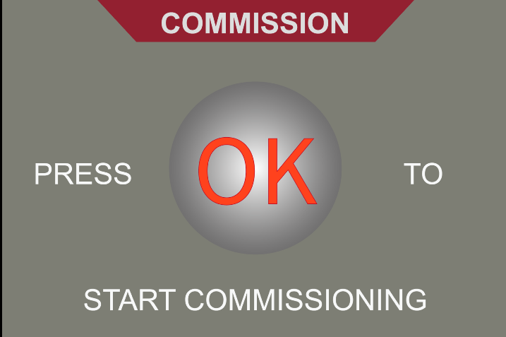

Figure 4.4. Start Screen: Program Mode

Normal Mode: While in “Normal Mode”, the unit is commissioned and operational. There are no system or sensor errors. In the Home screen, it also display the life cycle count.

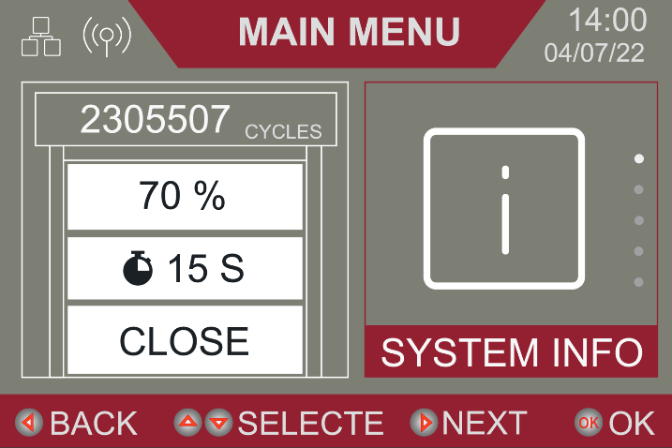

Figure .. Normal Mode

Override Mode: For curtain installation purpose or temporarily operate the door to open or close, we have designed Override mode. While in “Override Mode”, the unit is either has sensor failure error or have enabled “Override Mode Dip Switch” to enable the motor to roll the door without limit travel setting.



Figure .. Override Mode Dip Switch

### 

### Using the Menu Screen

The Menu Screen has three pieces of information displayed.

1. The title bar indicates the current menu selection.
2. The right window lets you know which settings you would be viewing if you press [ok] button to enter.
3. To left window gives the information about the door status, e.g. the shown picture means the door is 70% open position, 15 seconds timer counting to close and currently door status.

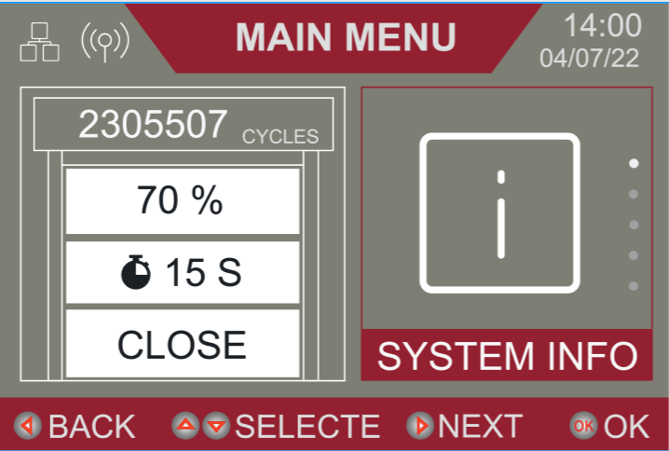

Figure .. Menu Screen

### Using the Options [1]Screen

The Options screen displays three pieces of information

* 1. Above the horizontal line shows the current page.
  2. The setting shows the available options for the parameter. The highlighted option shows which option will be selected when [OK] is pressed.

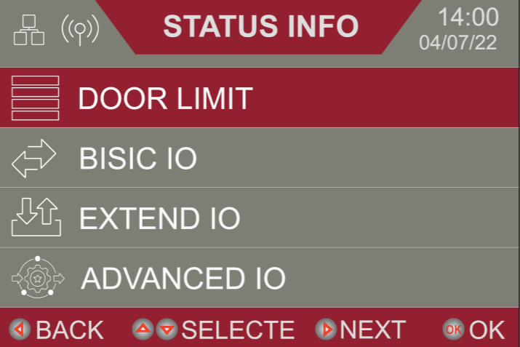

Figure .. Options Screen

### Using the Modify Settings Screen

The Modify Settings screen also displays three pieces of information

1. Above the horizontal band displays a parameter.   
   In this case, Close Timer Delay.
2. Below the horizontal line it indicates the current setting is 9999 seconds.
3. To edit the timer to delay, four navigation arrows will be used.

* The Up arrow raises the value by one each time it is pressed you press it.
* The Down Arrow decreases the value by one each time you press it.
* The left arrow changes the place value of the active digit to the left by one each time you press it. In this case, it changes the selection from ones to tens if pressed once, and from tens to hundreds if pressed again.
* The right arrow changes the place value of the active digit to the right by one each time you press it. (In this case, there are no decimal selections available, so it would changes the active value from ones to thousands if pressed once, and from thousands to hundreds if pressed again, etc.)

**NOTE:** In order to switch this screen from reading the option to modifying the settings, you must press the **OK** button. This causes the setting to become active, and the value to be highlighted. Once values have been changed to their desired settings, press **OK** to lock the values. You will know the value is locked when the highlight no longer flashes in the screen.

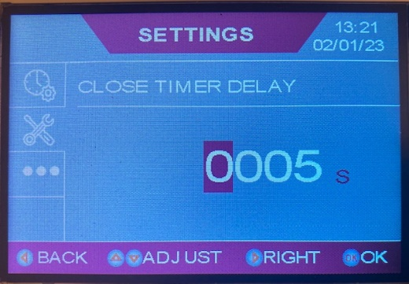

Figure .. Modify Settings Screen

## Status LEDs

System Inputs have corresponding Status LEDs for your convenience. There are three types of signals provided.

**Off** – Indicates that the device is not activated or connected.

**On** – Indicates that the device is activated, or monitored

**Blinking** – Inputs from Pulse-Train signal type monitored devices (like photo eyes from Fraba, Martec, or Micanan) will be blinking when they are connected as monitored, and all is working correctly.

|  |  |  |  |
| --- | --- | --- | --- |
| **System Inputs** | | | |
| **Menu Item** | **Default Status** | **Location** | **Standard Indication** |
| **Photo Eye Tx** | Testing input | Advanced | LED is on when powered |
| **Photo Eye Rx** | PNP Type Device | Advanced | LED is on when not triggered |
| **Sensing Edge** | Enables connection to a standard 2-wire sensing edge | Advanced | LED on when edge circuit is activated (Closed) |
| **Remote** | The connection for a single channel radio receiver | Advanced | LED on when receiver is getting signal from transmitter |
| **Light Curtain Tx** | Testing input | Advanced | LED is on when powered |
| **Light Curtain Rx** | PNP Type Device |  | LED is on when not triggered |
| **Remote Wired Open Button** | Enabled | Advanced | LED is on when OPEN Button is Pressed |
| **Remote Wired Close Button** | Enabled | Advanced | LED is on when CLOSE Button is Pressed |
| **Remote Wired Stop Button** | Enabled | Advanced | LED is on when the Stop Button **IS NOT** depressed |
| **Interlock** | Enabled | Advanced | LED off, Jumpered Terminals |
| **Activation** | Enabled | Advanced | LED is on when device activated |
| **VFD** | Enabled | Advanced | LED is flashing when work properly |

Table .4. System Inputs

|  |  |  |  |
| --- | --- | --- | --- |
| **Extended Module and IOs** | | | |
| **Module** | **IOs** | **Limitations** | **Notes** |
| **Programmable IOs,**  **EP0148** | 24VDC | 1 Amp Total output (shared  between external devices) | Larger power requirements will require an external power supply. |
| Relay outputs x 2 |
| Inputs x 2 | Relay inputs only | Need custom programmed logic |
| **Standard Module,**  **EP0149** | Fraba Photo Eye x 2 | Pulse train type Fraba Photo Eye units | Fraba 1&2 terminals works as input 1; Mid 1&2 works as input 2. |
| Aux. Edge | NO contact type input | Need activation in advanced menu; |
| COM1 | Relay inputs only | Upper limit relay |
| COM2 | Relay inputs only | Lower limit relay |
| **Auto Lock Module,**  **EP0147** | L1/S1 | Left side relay inputs | Compatible with Clopay Autolock only |
| L2/S2 | Right side relay inputs |
| R1/R2 | Left/Right lock driver |
| **Power Drive Module,**  **EP0146** | R1/2/3 | Relay COM for 1/2/3 drive | 3A/125VAC; |
| N/O | Normally Open Drive |
| N/C | Normally Closed Drive |

Table .5. System IOs

## System Reset (Manual)

There are two types of resets available to you in Basic Setting page on LCD.

1. Limit Reset: Only door travel limit setting will be cleared, all other settings will remain unchanged.
2. Factory Reset: Resets all settings back to factory original condition, including door travel limit, timers, sensor types, etc...

## Firmware update

1. First, you need a new firmware Micro-SD card from CornellCookson, then navigate the display to the page “**System Info**”.
2. To begin the process, you must insert and push in the Micro-SD card in the card slots, as shown in the picture. The LCD screen will display upgrade symbol.
3. Press “OK” button to upgrade the firmware. When finish, press the Micro-SD card left edge again to pop-out the card from card reader slot.



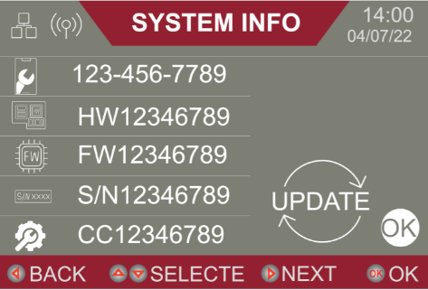

# Installation

## Mounting the Motor Operator

Refer to the installations that came with your door for mounting instructions for this motor.

CAUTION.JPG

**Ensure that the door has been properly aligned and is working smoothly by using the hand chain before connecting the unit to any power source.**

## Mounting the Control Panel

The control panel should ideally be mounted with the control buttons on the panel cover not less than 5 feet above the floor, and allow a wire run of not more than 20 feet to interconnect the motor and control panel.

CAUTION.JPG

**Wire runs longer than 20 feet should be cleared through the manufacturer prior to placing the order. If the distances requested are possible, special cabling supplied or specified by the factory will be required. Failure to do so could void the manufacturer’s warranty.**

The mounting location should provide a solid surface and be capable of supporting the weight of the control panel. Anchors will be included which are sized properly for the mounting slots in the control panel enclosure, and should be of a type appropriate for the wall construction. Care should be exercised to ensure the fasteners do not interfere with plumbing, conduit or power.

Cabling should be completed in a way that keeps the **low-voltage cables at least 6 inches from any line voltage or high voltage** wires throughout its entire length. Please take care to ensure that the intended cable routing does not leave you with cables that are too short to make the connections prior to final mounting of the control panel.

# Quick Start Guide

## Introduction

Please see **Section 7 Connections for Optional Control Accessories** when greater detail is required, or for clarification on items contained in this Quick-Start Guide. Fine tuning and adjustments detailed in other parts of this manual may be required to be performed as punch list items prior to final turnover of the job.

This Quick-Start Guide provides basic instructions for connecting the motor to   
the control panel, the control panel to the standard sensor package, and the incoming power   
to the door. Connections for approved and tested sensor and activation options that are not part of the standard sensor package are covered in Section – 7.

IMPORTANT:  
For help with connections, or questions about compatibility on accessories not covered in this manual, please call Tech Support at (855)-594-4969.

Note: All electrical work must be performed according to local and state building codes.



Figure 6.1. Standard APEX Pro Door Layout



## Control Panel

### Control Panel Structure

Figure 6.2 shows a typical internal control panel configuration.

Figure .2. Standard Control Panel Configuration

## Typical Motor Mounted VFD Power Connections



### Connect the Motor Power

Install the power disconnect near to the motor and VFD, for easy flexible conduit connection to the motor power terminals. The motor mounted VFD will provide power to the control panel by plug and play cable set. The same cable set also serve as communication wiring.

Figure .3. Standard APEX Pro VFD Connections



Figure .4. Optional Wall Mounted VFD Connections

## Drive and Tension Side Sensor Cables

### Connect the Drive and Tension Side Sensor Cables, Photo Eyes, and Light Curtains

Your door was shipped with two specialized quick disconnect cables with connectors pre-wired to the Apex Pro. panel. Both are fitted with the mated connectors for easy connection to the light curtain and photo-eye sensors. Both light curtain & photo eye connectors are color coded as follows. For both photo eyes and light curtains, red cable labels indicate Transmitter connections while yellow cable labels indicate Receiver connections.

Figure .5. Drive and Tension Side Sensor Cables

## Power Supply

### Connect Incoming Power

Connect incoming power as shown in Figure 6.4 and Figure 6.5. Refer to proper phase diagram depending on motor operator.



Figure .6. Motor Mount VFD Power Connection



Figure .7. Wall Mount VFD Power Connection

### 

### Final Steps

1. Review your wiring, double check all connections (including the factory wiring), and verify that there are no loose or broken wires.
2. Make sure all mechanical connections are completed and sealed.
3. Make sure the door installation is complete, with the door positioned at least 24” from each end of door travel.

Turn on the incoming power and follow the quick commissioning steps on the LED display, as detailed in Section – 8

# Connections for Optional Control Accessories

A variety of optional accessories are available for CornellCookson doors. This section describes how to connect each of these optional accessories to the control panel.

## About the Wireless Sensing Edge

If your order comes with a wireless sensing edge, follow the manufacturer’s instructions that come with the unit. Test the sensing edge with a continuity tester. When the edge is compressed, the reading should indicate continuity, when it is not compressed the reading should indicate an open circuit.

The NO connection is applicable to the Miller Edge MWATRA12 Wireless Edge Kit.

* Connect the Red Wire to Terminal 24V+.
* Connect the Black Wire to Terminal 24V-.
* Connect the Normally Open Relay Wire to either Primary Sensing Edge Terminal.
* Connect the Normally Open Relay Wire to the other Primary Sensing Edge Terminal.

Follow the manufacturer’s instructions for the transmitter connections and set-up.



Figure .. Wireless Sensing Edge.

## About External OPEN/CLOSE/STOP Stations

External OPEN/CLOSE/STOP Stations may be connected to the Panel using the terminals indicated in the detail below.

* OPEN and CLOSE contacts are normally open, and multiple devices are to be connected in parallel.
* Stop Circuits are normally closed, and multiple stopping devices would be wired in series so that activation of any 1 device results in an OPEN Circuit.

**IMPORTANT:**If an external O/C/S device is used, it is necessary remove the factory-installed jumper wire between the Common and Stop terminals on the control board.



Figure .. External Control Stations.

## About the Motion Detector

The following is applicable to the BEA FALCON or FALCON XL Motion Detector, Loop detectors.

* Connect the Red Wire to terminal 24+.
* Connect the Black Wire to terminal 24-.
* Connect the (COM)- Wire to Terminal COM.
* Connect the (N/O Relay) Wire to Terminal IN.

Follow the manufacturer’s instructions for the transmitter connections and set-up.



Figure .. Motion Sensor

## About Radio Controls / Digital Keyless Entry / Open/Close Devices

SmartSync wireless Receiver (Clopay SmartSync Wireless receiver remote terminal: IM201430) is typically connected as follows:





Figure .. Single Channel Radio Receiver





Figure .. Three Channel Radio Receive

## Extended Standard Module

WARNING.JPG

**On STANDARD EXTENDED MODULE, THE LIMIT OUTPUTS ARE LIMITED TO SWITCHING DEVICES WITH A LOAD OF 200MA OR SMALLER, FOR 24VAC/DC CONTROL VOLTAGE ONLY. IF LARGER OUTPUTS ARE REQUIRED, THESE CONTACTS CAN BE USED AS DRIVERS FOR A CONTROL RELAY WITH ADEQUATELY SIZED CONTACTOR FOR YOUR NEEDS.**

There is a Common, Normal Open, Normally Closed contact available for both Open and Closed door positions. Fraba Photo Eye, Middle Fraba Photo Eye and Aux Sensing Edge inputs can be wired thru the Standard Extended Module. The activation of the these inputs can be referred to Advanced Setting options.



Figure .. Standard Extended Module

# System Start-Up and Operation

## Extended Optional Modules

Optional Autolock module is a driving device for Autolock, which will be automatically selected if an Autolock mechanical device is selected in door configuration.



Figure .. Optional Autolock Module

Optional Power Relay Module can be ordered separately if there is situation to drive a 120VAC to 240VAC applications, such as fan, alarm, lights, etc… The nominal power rating is 3A for 120VAC. There are three (3) programmable relays (R1, R2, R3) which can be programmed separately in Extended Module options in menu.



Figure .. Optional Power Relay Module

## Commissioning (Program Mode)

This section includes the required steps and on-screen prompts used when commissioning the door limits. While the Apex Pro. has been designed to walk you through the commissioning sequence automatically, the steps and supplementary information should be referenced if there is any question as to what is occurring or what the on-screen prompts mean.

NOTE: **Pressing the STOP button anytime during the initial commissioning process will restart the sequence from the beginning.**

**Press OK to Start Commissioning**

When this menu appears on your screen, it is usually the first time the unit has been powered up, or someone has performed a **Limit Reset** command. The digital limits have not been set, and you will need to perform a basic commission of the door before it can be used electrically.

Follow the on-screen instructions to run through the commissioning sequence.

* If there is a DES Encoder Error, the system goes into override mode to allow constant pressure operation only until the error is resolved. Refer to Section 9 for troubleshooting tips.

**Is the Door More than Two Foot from each End?**

Turn the DIP switch to the right of LCD to activate the override mode and use [OPEN] or [CLOSE] button to move the door if the door is not at least 2 ft above the bottom of the opening or 2 ft below the desired upper limit.

**Note: Be aware that the door moving direction may be reversed, but it is normal in this step, it will auto correct itself in the next step.**



If there is no power, Pull the Red handle to engage the Manual Chain to operate the door.

**Press AND Hold [OK] FOR 2 SECONDS to Start the Phase Check (Chain drive motor only)**

The operator is waiting for confirmation before beginning a phase or motor rotation check. If motor rotation is reversed, the controller will determine this and auto correct motor rotation.

Follow these steps to start the Phase Check:

1. Verify that the opening is free of obstructions and the door is positioned as instructed in the previous step. Once you press the **Open + Close simultaneously**, the auto phase checking will begin. It is normal for the door to travel up to 2 feet in both directions during this process.
2. Press the **OK** button to begin. The door will start jogging up and down to verify the motor phase.
3. If the curtain becomes jammed during the phase checking process, quit the sequence by pressing the **STOP** button. Correct the problem and start the commissioning process from the beginning.

**Auto Phase Check is Complete—Press OK**

Press **OK** to acknowledge that the auto phase check has been performed.

**Open Door to Desired Open Limit Next [OK]**

1. The **OPEN** on the panel cover drives the door at slow speed. The door stops when the **OPEN** button is released. Keep in mind that no travel limits have been set. The door will not stop at the top of the opening unless you release the **OPEN** button.
2. Press the **OK** button to confirm.

Note: If you overshoot the desired position, you may use the CLOSE control in the same manner to lower the door. Jog the door OPEN or CLOSED as needed to get the door to the desired position.

**Did Door Reach Open Limit? [Stop] – No Yes [OK]**

Press OK to confirm that the door is at the desired fully open position.

Note: The system performs a sensor check to verify functionality of the light curtains and photo-eyes during this step. If there is a functionality issue with these sensors, you will see a SENSOR CHECK FAIL message on the LED screen. Please check the shorter cable connections in drive side and longer cable connections in tension side.

**Press Close to Close Door at Low Photo-eye**

1. Press and maintain pressure on the **Close** control to lower the door.
2. As the door passes the lower photo-eye, it will activate the device, and the door should stop there.

**Note:** Releasing the button will stop the door while in **Program Mode**.



**Did Door Stop at Low Photoeye? [Stop]-No Yes-[OK]**

By pressing **OK** you are confirming that the door stopped (automatically) at the lower photo eye height.

Press **OK** to confirm.

**Now Jog To Tune Close Limit Next [OK]**

Use the close control to lower the door to the fully closed position. If you overshoot the desired door position, the open control can be used to raise the door. When the door is in the desired position go to next step.

**If Door Reach Close Limit Confirm – [OK]**

Press **OK** to confirm that the door is at the desired fully closed position

**Setup Is Done Fine-Tune In Menu Press [OK] To Confirm**

Once **OK** is pressed, the door will switch to **Standby Mode** and it will hold there for 30 seconds. Once 30 seconds has elapsed, or ANY Control button been pushed, the unit will switch to **Normal Mode.**

**CAUTION.JPG**

**DIP switch to lock the button functions:**

**The first DIP switch in lower position will disable all buttons’ functionality.**

**The second DIP switch in lower position will only disable the navigation buttons’ functionality.**





Figure .. Disable Button Functionality Dip Switch

**Note:** Due to the difference in operational speed of door operation between **Program Mode** and **Normal Mode**, a slight variation between the limit position during **Normal Mode** and the limits established during Program Mode may exist.

Please access the Main Menu Items 5, 6, 7, and 8 below for instructions on fine tuning the **Norma**l **Mode** over travel limits.

## Time Setting and Basic Setting Items

1. To access the main menu items from the Normal Mode of the operator, Use the [↑] or [↓] buttons to find Setting page and press the [OK] button to enter.
2. Use the [↑] or [↓] buttons to select Basic Settings and press the [OK] button to enter.
3. Use the [←] button to return to main page.

| **Menu Name** | **Menu Number** | **Display Indicates** | **Remarks** | **To Adjust Settings:** |
| --- | --- | --- | --- | --- |
| **Time Setting** | 1 | Setting date and time in this menu | The Apex Pro. is installed with battery to save the calendar even without power. | Select the digit by pressing [→] , change the setting by using the [↑] or [↓]. Press OK to accept the change. Press [←] to return. |
| **Mid Stop Open %** | 2 | The current setting of the operating programming. | A value of 100% means there is no mid-stop function setting on the door.  A value between 30% and 99% indicates that a mid-stop position has been selected. When a mid-stop is required, ensure the mid-stop position is high enough that the light curtains are not activated by the door when stopped at the mid-stop position.  If a level below the top of the light curtains is required, there are only two options:  Install a shorter set of light curtains so that the mid-stop level does not activate the light curtain.  Remove the light curtains from the system and select another obstruction detection option to keep the opening as safe as possible. | * You may adjust the value anywhere between 30% and 100% by using the [↑] or [↓] arrow on the control panel cover. * Pressthe **OK** button to accept changes (The value on the screen should cease to flash) * Press [←] to return to **Run** mode, but no change will be saved. |
| **Close Timer Enable** | 3 | **DISABLE**, **ENABLE and Cross_Init_Mode**  The highlighted value is the active setting. | A setting of **DISABLE** means that you selected the No Timer to Close Function  A setting of **ENABLE** means that you wish to set a value to automatically close the door after a specified time delay.  The timer countdown will begin when the door reaches the position indicated by the “MID STOP OPEN %” (Menu Number 2 above)  Press STOP button at Open limit will disable the Timer To Close function until the activation device has been triggered.  When the mid-stop feature is selected, the timer to close does not activate from the fully open position.  If an activation device (light curtain, photo-eye, etc.) is triggered prior to the countdown timer initiating door closure, the timer will reset to the close timer delay value. (*Menu Item 4*  *below).*  A Setting of **Cross_Init_Mode** means that The timer will start counting after the light_curtain and/or low photo eye is triggered and unblocked. | * Use the [↑] or [↓] arrow until the desired selection is highlighted. * Press the **OK** button or [←] to accept the changes and return to the main menu   Proceed to (m*enu Item 4 below)* if the timer to close is enabled to adjust the time delay interval for timer activation. |
| **Close Timer Delay** | 4 | The current setting for the time delay interval for the timer to close. | This setting has no effect on door function unless “CLOSE TIMER ENABLE” *(Menu Item 3 above)* is set to **ENABLE**.  The timer is adjustable from 1 to 9999 seconds *(Maximum of 2 hours, 46 minutes, 39 seconds)* | * The [↑] arrow will raise the value by 1 each time it is pressed * The [↓] arrow will decrease the value by 1 each time it is pressed. * The [←] arrow will change the place value of the active digit to the left by 1 each time it is pressed. (In this case it would change the selection from *ones* to *tens* if pressed once, and from *tens* to *hundreds* if pressed again, etc.) * The [→] arrow will change the place value of the active digit to the right by 1 each time it is pressed. (In this case, there are no decimal selections available, so it would change the active value from *ones* to *thousands* if pressed once, and from *thousands* to *hundreds* if pressed again, etc.)   Press the OK button to accept the change; or [←] to return to the main menu without change saved. |
| **Adjust Open Stop** | 5 | A value in encoder pulses which establishes an approximate distance from the original Stop position set up in the basic set-up menu. | Due to variations in door height and weight, there is often some slight variation in the final stopping position of the door compared to the position selected during the initial basic door set-up. If it is necessary to fine tune the stopping position of the door, it is necessary to observe which of two conditions exist before adjusting this setting.  **NOTE:** The **XXX** value on the display is just a programmed estimate of the distance of the proposed changes. “Positive” will travel further; “Negative” will stop sooner. Because coil sizes vary with door height and the thickness of the curtain selected, it will vary from actual distance of change caused by the adjustment to this setting. | * **Condition 1** – There is no discernible intermediate step in speed between full speed and stop. Speed ramping down is observed, but the slower speed does not stabilize prior to the door stopping.   + Move immediately to menu item 7 *(Below)* and adjust as needed. * **Condition 2** - There is a discernible intermediate step in speed between full speed and stop. Speed ramping down is observed, and the slower speed stabilizes prior to the door stopping.   + Press the [↓] or [↑] button as necessary to adjust value up or down in small (from 1 to 5) increments.   + Press **OK** to accept changes and return to  **Normal Mode** cycle door and observe the Open Stop position   + Repeat as necessary |
| **Adjust Close Stop** | 6 | A value in encoder pulses which establishes an approximate distance from the original Stop position set up in the basic set-up menu. | Due to variations in door height and weight, there is often some slight variation in the final stopping position of the door compared to the position selected during the initial basic door set-up.  If it is necessary to fine tune the stopping position of the door, you need to observe which of two conditions exist before adjusting this setting.  **NOTE:** The **XXX** value on the display is just a programmed estimate of the distance of the proposed changes. Because coil sizes vary with door height and the thickness of the curtain selected, it will vary from actual distance of change caused by the adjustment to this setting. | **Condition 1** – There is no discernible intermediate step in speed between full speed and stop. Speed ramping down is observed, but the slower speed does not stabilize prior to the door stopping.   * Move immediately to section menu item 8 (below) and adjust as necessary.   **Condition 2** - There is a discernible intermediate step in speed between full speed and stop. Speed ramping down is observed, and the slower speed stabilizes prior to the door stopping.   * Press the [↓] or [↑] button as necessary to adjust value up or down in small (from 1 to 5) increments. * Press OK to accept changes and return to NORMAL MODE. * Cycle the door and observe the Close Stop position. * Repeat as necessary. |
| **Open Ramp Area** | 7 | A value as a percentage of the total of barrel turns to raise or lower the door from full open to fully closed or fully closed to fully open. | Due to variations in door height and weight, there is often some slight variation in the final stopping position of the door compared to the position selected during the initial basic door set-up.  If it is necessary to fine tune the stopping position of the door, it is necessary to observe which of two conditions exist before adjusting this setting.  **NOTE:** It is normal for this value to be different at the top of the opening and the bottom of the opening. The coil size is larger when the door is open than it is when the door is closed. Therefore, the distance that the curtain travels per barrel turn will be different at the top and bottom. | **Condition 1** – There is a discernible intermediate step in speed between full speed and stop. Speed ramping down is observed, and the slower speed stabilizes prior to the door stopping.   * Move immediately to menu item 5 (above) and adjust as necessary.   **Condition 2 -** There is no discernible intermediate step in speed between full speed and stop. Speed ramping down is observed, but the slower speed does not stabilize prior to the door stopping.   * Press the [↓] or [↑] button as needed to adjust value up or down in 1% increments. * Press **OK** to accept changes and return to **Normal Mode** * Cycle the door and observe the Open ramp characteristics. * Repeat as needed.   **NOTE:** Excessive travel at the slow speed prior to the door stopping is not necessary, and extends the length of time it takes the door to cycle. You may adjust this setting to minimize the time the door stays at the slow speed while ramping down. |
| **Close Ramp Area** | 8 | A value as a percentage of the total of barrel turns to raise or lower the door from full open to fully closed or fully closed to fully open. | Due to variations in door height and weight, there is often some slight variation in the final stopping position of the door compared to the position selected during the initial basic door set-up.  If it is necessary to fine tune the stopping position of the door, it is necessary to observe which of two conditions exist before adjusting this setting.  **NOTE:** It is normal for this value to be different at the top of the opening and the bottom of the opening. The coil size is larger when the door is open than when the door is closed. Therefore, the distance that the curtain travels per barrel turn will be different at the top and bottom. | **Condition 1** – There is a discernible intermediate step in speed between full speed and stop. Speed ramping down is observed, and the slower speed stabilizes prior to the door stopping.   * Move immediately to menu item 6 (above) and adjust as necessary.   **Condition 2** - There is no discernible intermediate step in speed between full speed and stop. Speed ramping down is observed, but the slower speed does not stabilize prior to the door stopping.   * Press the [↓] or [↑] button as necessary to adjust value up or down in 1% increments. * Press **OK** to accept changes and return to  **Normal Mode** * Cycle the door and observe the Open ramp characteristics. * Repeat as necessary   **NOTE:** Excessive travel at the slow speed prior to the door stopping is not necessary, and extends the length of time it takes the door to complete a cycle. You may adjust this setting to minimize the time the door stays at the slow speed while ramping down. |
| **Factory Setting** | 9 | Current State of this menu Item. The default setting for this is **DISABLE.** | All parameters in control and VFD tweaks that have been performed since installation can be reset to their original factory settings here. If you want to reset limits only, please proceed to Menu Number 10-LIMIT CLEAR.  **NOTE**: If you select **ENABLE** and press **OK** to accept the changes, THIS CANNOT BE UNDONE. | * Press[**↓**] or [↑] to make desired selection   Press **OK** to accept changes and go to **PROGRAM** mode (Section 8 - System Start-Up and Operation) |
| **Limit Clear** | 10 | Current State of this menu Item. The default setting for this is **DISABLE** | This parameter enables a reset of the open and close travel limits but leaves all other system tweaks that have been performed since installation to remain. If you need to make a complete restore to original factory settings, please see *(Menu Item 9 above)*  **NOTE:** If you select **ENABLE** and press OK to accept the changes, THIS CANNOT BE UNDONE. | * Press[↓] or [↑] to make desired selection * Press the **OK** button to accept changes and go to “PROGRAM MODE” (Section 8 - System Start-Up and Operation) |
| **Up Limit Position** | 11 | A six-digit value that represents an encoder position that has been established as the open travel limit position during the set-up process. | Info Only! | This menu item is read only. No adjustment is possible. |
| **Low Limit Position** | 12 | A six-digit value that represents an encoder position that has been established as the close travel limit position during the set-up process. | Info Only! | This menu item is read only. No adjustment is possible. |
| **Door Position** | 13 | A value that indicates the current position of the door as a percentage of open. | This is representative of a percentage of the total barrel turns to fully open or close the door, not as a percentage of distance. | This menu item is read only. No adjustment is possible |
| **Door Direction** | 14 | A real-time display of the current door operation (as seen by the motor controller) | If this menu is active on the display, and the door is traveling or travel is initiated, the display will indicate which direction the control thinks the door is traveling. If the door is not moving, the display should indicate “STOP”. | This menu item is read only. No adjustment is possible. |
| **Encoder Position** | 15 | A six-digit value representing the current encoder position | NONE | This menu item is read only. No adjustment is possible |
| **Reserved** | 16 | NA | NA | NA |
| **Changed to Reversed** | 17 | A Value of “0” or “1” | A value of “0” means that no rotation correction has been applied. A value of “1” indicates that automatic rotation correction has been applied to make the door open when an open command is received. This is established in the initial setup process. | This menu item is read only.  No adjustment is possible. |
| **Reserved** | 18 | DISABLE | This menu item is not currently active. | Not Active – Do Not Adjust |
| **Reserved** | 19 | DISABLE | This menu item is not currently active. | Not Active – Do Not Adjust |
| **Reserved** | 20 | DISABLE | This menu item is not currently active. | Not Active – Do Not Adjust |
| **Reserved** | 21 | DISABLE | This menu item is not currently active. | Not Active – Do Not Adjust |
| **Reserved** | 22 | DISABLE | This menu item is not currently active | Not Active – Do Not Adjust |
| **Up Limit Out Status** | 23 | DISABLE or ENABLE | This is a dry contact output rated for control voltages and currents only. This is not to be use to route power supply voltage used to power accessories or other components. Total current of all outputs should not exceed 200mA.  When enabled, this contact will provide continuity when the door is at the open travel limit. active. | * Press[↓] or [↑] to make desired selection * Press the **OK** button to accept changes and return to **Run mode** |
| **Low Limit Out** | 24 | DISABLE or ENABLE | This is a dry contact output rated for control voltages and currents only. This is not to be use to route power supply voltage used to power accessories or other components. Total current of all outputs should not exceed 200mA.  When enabled, this contact will provide continuity when the door is at the open travel limit. active. | * Press[↓] or [↑] to make desired selection * Press the **OK** button to accept changes and return to **Run mode** |
| **Reserved** | 25 | **DISABLE** | This is not an active menu item | Do Not Adjust. |
| **Reserved** | 26 | **DISABLE** | This is not an active menu item | Do Not Adjust. |
| **Thermal Interlock Status** | 27 | “TRIGGERED” or “UNTRIGGERED” | **Input** - N/C is Normal State. If the display reads “TRIGGERED”, there has been a thermal issue detected in the brake resistor. If this doesn’t correct itself within 30 minutes or it is a recurring error, call **Technical Support at (855)-594-4969** for assistance. | This menu item is read only.  No adjustment is possible. |
| **Inertial Interlock Status** | 28 | “TRIGGERED” or “UNTRIGGERED” | **Input** - N/C is Normal State. On doors equipped with an inertia brake (See the Door installation and maintenance manual) if the display reads “TRIGGERED”, there has been an issue detected with the inertia brake, or the wiring from the inertia brake has been compromised. | This menu item is read only.  No adjustment is possible. |
| **Manual Chain Lock Status** | 29 | The status of the manual hand chain interlock switch as “TRIGGERED” or “UNTRIGGERED” – “UNTRIGGERED” is normal. | **Input** - N/C is Normal State. A “TRIGGERED” status will electrically prevent the door from operating electrically. | This menu item is read only.  No adjustment is possible. |
| **External Interlock Status** | 30 | The status of the external interlocks – “TRIGGERED” or “UNTRIGGERED”. The standard would be “UNTRIGGERED, and would indicate that there is continuity across the input terminals. This may indicate that door locks are activated, or that another interlocked system isn’t ready for the door to be operable. | **Input** - N/C is Normal State. | This menu item is read only.  No adjustment is possible. |
| **DES Interlock Status** | 31 | The status of the DES Encoder interlock on the motor (This device is used to maintain travel limits and door position information) – “TRIGGERED” or “UNTRIGGERED”. | **Input** - N/C is Normal State. The standard would be “UNTRIGGERED, and would indicate that there is continuity across the input terminals. This may indicate there is a wiring issue between the operator and the controller, or a problem with the DES Encoder. | This menu item is read only.  No adjustment is possible. |
| **Motion Detector Status** | 32 | Motion Detector Status – “TRIGGERED” or “UNTRIGGERED” | N/O is Normal State | This menu item is read only.  No adjustment is possible. |
| **Loop Detector Status** | 33 | Loop Detector Status – “TRIGGERED’ or “UNTRIGGERED” | **Input** – N/O is Normal State | This menu item is read only.  No adjustment is possible. |
| **Auxiliary In1 Status** | 34 | UNTRIGGERED | This is not an active menu item. | Do Not Adjust. |
| **Auxiliary In2 Status** | 35 | UNTRIGGERED | This is not an active menu item. | Do Not Adjust. |
| **Fraba Up Photoeye Status** | 36 | UNTRIGGERED | This is not an active menu item. | Do Not Adjust. |
| **FRABA Low PhotoEye Status** | 37 | TRIGGERED | This is not an active menu item. | Do Not Adjust. |
| **Telco Up PhotoEye Status** | 38 | UNTRIGGERED | This is not an active menu item. | Do Not Adjust. |
| **Telco Low PhotoEye Status** | 39 | UNTRIGGERED | This is not an active menu item. | Do Not Adjust. |
| **Basic Safety Sensing Edge Status** | 40 | The Status of the monitored Sensing Edge (If Equipped) | For use with a 10K Ohm resistive terminated Sensing Edge only. The display will read “UNTRIGGERED” or “TRIGGERED” | This menu item is read only.  No adjustment is possible. |
| **Auxiliary Safety Edge Status** | 41 | The status of an unmonitored Normally Open Sensing Edge (If Equipped) | The display will read “UNTRIGGERED” or “TRIGGERED” | This menu item is read only.  No adjustment is possible. |
| **Auxiliary FRABA Med PhotoEye Status** | 42 | TRIGGERED or UNTRIGGERED | This gives the status of a second set of photo eyes (Pulse Train Output Type). This menu Item would need to be enabled in the advanced. Call **Technical Support for assistance at (855)-594-4969**. | This menu item is read only.  No adjustment is possible. |
| **Auxiliary FRABA PhotoEye 1 Status** | 43 | TRIGGERED | This is not an active menu item. | Do Not Adjust. |
| **Auxiliary FRABA PhotoEye 2 Status** | 44 | TRIGGERED | This is not an active menu item. | Do Not Adjust. |
| **TELCO Light Curtain Status** | 45 | The Status of the Light Curtains | Display will read “TRIGGERED” or “UNTRIGGERED” | This menu item is read only.  No adjustment is possible. |
| **About** |  |  | This menu item displays the Firmware Version and Revision of the software program in the board. It also provides the phone number to contact **Technical Support at (855)-594-4969.** |  |

Table .. Main Menu Items

## Advanced Setting items in More Settings

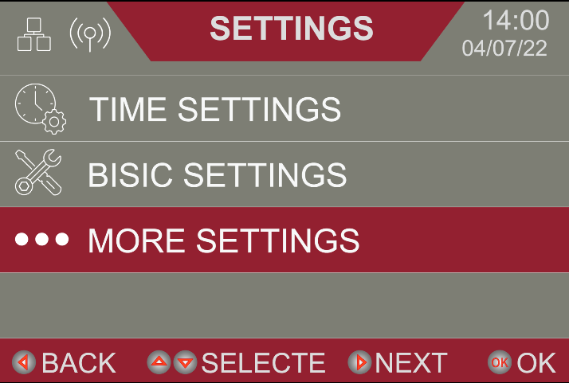

Terminals designated as inputs will have LED indicators on the board there are 3 states of the LEDs on the board.

* + **OFF** – Not Activated in Menu
  + **ON** – Activated
  + **BLINKING** – This will be available only on devices with a pulse train communication.There will be no blinking with PNP devices
* Any Menu Item where multiple selections are possible, the options will be shown, and the factory default setting will be indicated in ***bold, italic*** print.

|  |  |  | **LED Indicators** | | |
| --- | --- | --- | --- | --- | --- |
| **Item** | **Settings** | **Description** | **On** | **Off** | **Blinking** |
| Upper Photo Eye | ***NA*** | ***No Device is being used*** | Sensor is active | ***Nothing selected/not active*** | Pulse train sensors enabled connected and working properly |
| Fraba | PNP type device with blanking feature |
| Telco-W-Monitor | PNP device with blanking feature |
| Telco-WO- Monitor | Not used |
| Lower Photo Eye | N/A | No device being used | Sensor is active | ***Sensor is not active*** | Pulse train sensors enabled, connected, and working properly |
| Fraba | Fraba or approved pulse-train type photo eyes |
| ***Telco-WO- Monitor*** | ***PNP device with blanking feature*** |
| Basic Sensing Edge | NA | No Device is being used | Sensor is active | ***Sensor is* *not active*** | Not Applicable |
| ***Universal*** | ***Standard-normally open edge is being used*** |
| 10k resistor type | 10k Ohm resistive edge is being monitored |
| Auxiliary Sensing Edge | NA | No device being used | Sensor is active | ***Sensor is not active*** | Not Applicable |
| ***Universal*** | ***Standard-normally open edge is being used*** |
| 10k resistor type | 10k Ohm resistive edge is being monitored |
| Remote | NA | No device being used | ***Device is active*** | Device is not inactive | Not Applicable |
| ***1Key remote*** | ***1 channel radio receiver/.transmitter*** |
| 2Key remote | Not available at this time |
| Encoder Type | NA | No device being used | ***Device is active*** | Device is not inactive | Not Applicable |
| ***GFA DES*** | ***GFA hollow-shaft operator is on door*** |
| BTA | Not available at this time |
| Light Curtain | NA | No device being used | ***Device is not active*** | Door is obstructed | Not Applicable |
| ***Connected*** | ***TELCO light curtains used on door*** |
| Thermal Interlock | NA | No device being used | ***Circuit is Closed*** | Circuit Open | Not Applicable |
| ***Connected*** | ***Thermal interlock on brake resistor is NC*** |
| Inertia Interlock | NA | No device being used | ***Circuit is closed*** | Circuit open | Not Applicable |
| ***Connected*** | ***None with GFA motor operator*** |
| Manual Chain Interlock | NA | No device being used | ***No device being used*** | Electric operation enabled | Not Applicable |
| ***Connected*** | ***Door inoperable when hoist chain is used*** |
| External Interlock | NA | No device required | ***Circuit is Closed*** | No interlock in place |  |
| ***Connected*** | ***Locks or external equipment interface needed*** |
| DES Interlock | NA | No device being used | ***Electrically functional*** | No interlock in place | Not Applicable |
| ***Connected*** | ***Disables electrically when chain hoist is engaged*** |
| Mid Fraba  Photo-Eye | ***NA*** | ***No device being used*** | Electrically functional | ***No device connected*** | Pulse train sensors enabled |
| Connected | Device connected |
| Aux Fraba  Photo-Eye 1 | ***NA*** | ***Not used-***  ***Not applicable*** | Electrically functional | No interlock in place | Not Applicable |
| Aux Fraba  Photo-Eye 2 | ***NA*** | ***Not used-***  ***Not applicable*** | NA | NA | NA |
| Motion Detector | **Connected** |  | Motion detector activated | ***Motion detector is not activated*** | Not Applicable |
| NA | No device being used |
| Loop Detector | **Connected** |  | Motion detector activated | ***Loop detector is not activated*** | N/A |
| NA | No device being used |
| Rated Power | 1/8 hp | The value represents the rated output current of the Variable Frequency Drive (VFD) selected for your application.  This value was set at the factory, it will be reset to factory original condition after factory reset. | | | |
| ¼ hp |
| ½ hp |
| 1.0 hp |
| 2.0 hp |
| 3.0 hp |
| 5.0 hp |
| 7.5 hp |
| 10.0 hp |
| Operating Power | 1/8 hp | The value represents the rated output current of the motor selected for your application.  This value was set at the factory | | | |
| ¼ hp |
| ½ hp |
| 1.0 hp |
| 2.0 hp |
| 3.0 hp |
| 5.0 hp |
| 7.5 hp |
| 10.0 hp |
| Shaft |  | The parameter is not being used at this time.  DO NOT ADJUST | | | |
| Slat Thickness |  |
| Opening Height |  |
| Opening Speed |  |
| Close Speed |  |

Table .2. Advanced Menu Items

# System Status Messages

| **Display Reads** | **Description** | **Action Required** |
| --- | --- | --- |
| **VFD COM ERROR** | VFD Communication Error | 1. Verify the RJ45 Cable is properly connected. 2. Cycle the power off. 3. Re-establish the connection. 4. Power the unit back on. |
| **ENCODER ERROR** | Encoder error | 1. Verify that the encoder is properly connected. 2. Cycle the power off. 3. Re-establish the connection. 4. Power the unit back on. |
| **Thermo-Interlock** | Brake Resistor is too hot | 1. The brake resistor is too hot if the surface temperature is above 200o F, there is cause for concern. 2. Reduce the door cycling rate. 3. Check thermo-interlock connectivity. |
| **Inertia-Interlock** | The N/C inertia brake connection is reading as Open. | 1. Verify the factory installed jumper is properly installed. 2. For 1024 application, please check the Inertia brake. |
| **Backwind Sensor Activated** | Not currently an option. | N/A |
| **VFD Error** | Physical VFD and system settings do not match. | 1. Contact Technical Support at (855)-594-4969. |
| **VFD Fault** | VFD has internal fault | 1. Cycle Power Off. 2. Wait 10 Seconds. 3. Turn Main Power back on. 4. If issue still exists, contact technical support at (855)-594-4969. |
| **Overload Current** | The Motor is taking too much current to operate the door. | 1. Verify that the incoming voltage is correct and that all phases are present. 2. Check the mechanics of the door to ensure that there is no mechanical binding. 3. Contact Technical Support. |
| **Brake Drive  Broken** | The solenoid brake circuit is malfunctioning. | 1. Contact Technical Support at (855)-594-4969. |
| **Sensing Edge Activation** | Sensing edge is activated, or not connected properly. | 1. Check status of sensing edge with a multi-meter. 2. Contact Technical Support at (855)-594-4969. |
| **Motor Chain Handle Engaged** | The chain hoist interlock connection is OPEN. | 1. Disengage hoist interlock. 2. Check across hoist interlock terminals for continuity. 3. Contact Technical Support at (855)-594-4969. |
| **Low Photo Eye Activation** | There is an issue with the primary photo eyes. | 1. Verify that the photo eyes are not obstructed, properly aligned, and connected. 2. Contact Technical Support at (855)-594-4969. |
| **Middle Photo Eye Activation** | If you are using a second set of photo eyes there is an issue with them. | 1. Verify that the photo eyes are not obstructed, properly aligned, and connected. 2. If Mid PE is not needed, deselect it in advanced menu,Contact Technical Support at (855)-594-4969. |
| **External Interlock** | There is a loss of continuity across the external interlock terminals. | 1. Verify that all devices interlocked with the door are providing a normally closed contact. 2. If no devices are being used, reinstall the jumper across the terminals. |
| **Curtain Lock Activation** | Curtain knock out function is not used with this product. | 1. Contact Technical Support at (855)-594-4969. |
| **Light Curtain Activation** | Light Curtain activation is sensed. | 1. Verify that light curtains are connected, aligned properly, and that the lenses are not obscured by an obstruction, peripherals, or dirt and/or grime. 2. Contact Technical Support (855)-594-4969. |
| **Motion Detector Activation** | Motion Detector activation is sensed. | 1. Verify that the motion detector is connected properly, and that the target area is free from movement. 2. Verify the motion detector connection is NO 3. Contact Technical Support |
| **Loop Detector Activation** | Loop Detector activation is detected. | 1. Verify that the loop detector is functioning properly 2. Verify the Loop detector connector is NO 3. Contact Technical Support at (855)-594-4969 |

Table .1. System Status Messages

# Schematics

## Plug & Play Wiring Details

### Motor to Apex Pro. Panel Connections



Figure .. VFD Terminal Connections

## Pre-Wired Motor Mounted VFD Apex Pro Components

* Variable Frequency Drive
* Power Board
* 24VDC power supply
* Printed Circuit Board
* Brake Resistor and Thermocouple

### Drive Side Sensor Package Cables Connections



Figure .. Drive Side Sensor Package Cables Connections

### Y-Connector Tension Side Sensor Package Cable Connections



Figure .. Y-Connector Cable Connections

# Maintenance

## Maintenance Schedule

COORDINATE OPERATOR MAINTENANCE SCHEDULE WITH THE MANUFACTURER’S MAINTENANCE SCHEDULE FOR YOUR DOOR

Gearbox – The gearbox on the motor operator is factory sealed, and should not require service for the life of the operator.

Brake Friction Material - The electromagnetic brake on the motor operator is factory adjusted, and should not require service for the life of the operator.

CAUTION.JPG

***Before servicing, always disconnect the Operator from the Power Supply.***

* Use Schaeffer’s #227 Moly Roller Chain Lube or DuPont Teflon Chain Saver Lubricant on roller chains (*when present*)
* Do not lubricate motor. Motor bearings are lubricated at the factory.
* Inspect and service whenever a malfunction is observed or suspected.

**For Technical Support please call (855)-594-4969.**

## Motor Operator Maintenance

Door operators require practically no special maintenance other than periodic checking to see that mechanical parts where necessary are lubricated and the electrical components are free of dirt and other possibly conductive or corrosive materials.

Service technicians should familiarize themselves with the proper sequence of operation and all related controls. Power to the operator must be disconnected when removing or replacing covers on electrical components, making adjustments, or performing maintenance.

1. Check wire connections for tightness and wire insulation for defects or abrasions.
2. Check to see that all conduit connections are secure.
3. Check wires to sensing edge or photo ice.
4. Inspect gearbox for leaks.
5. Inspect operation of break.
6. Tighten any set screws.
7. Generally inspect the motor mounting and tighten the fasteners and bracing.
8. Verify that all conduit connections are tight and have no exposed wires.
9. Inspect electrical enclosure for debris, arcing and moisture. Check for and tighten loose wiring connections.
10. Test motor operation through all control stations.
11. Examine the sensing edge *(if equipped)* for damage and proper operation.
12. Test the operation of the sensing edge *(if equipped).*

Check motor amperage draw for (1ea) full open and (1ea) full close cycle. Compare readings to those listed on the motor nameplate.

# Troubleshooting

## Troubleshooting Table

| **PROBLEM** | **POSSSIBLE CAUSE** | **CORRECTIVE ACTION** |
| --- | --- | --- |
| **Sensor Check Fail** occurs during commissioning sequence.  *With* ***Sensor Check Fail*** *the control will be in the* ***Override Mode****. Press and hold the* ***Open*** *or* ***Close*** *for 5 seconds to jog the door. Door direction may be reversed.* | Sensor functionality check failed, commissioning cannot be completed | Verify that the Light Curtain and the Photo-eyes are not blocked |
| Check the **LONG** sensor cable should route to **TENSION** side, the **SHORT** cable to the **DRIVE** side. |
| Check and repair the wiring as needed between Sensor Cables to the motor control panel |
| **“DES Encoder Error”** during commissioning sequence.  *With* ***Sensor Check Fail*** *the control will be in the* ***Override Mode****. Press and hold the* ***Open*** *or* ***Close*** *for 5 seconds to jog the door. Door direction may be reversed.* | PC Board is not detecting signal from the DES Encoder | Check cabling and connection at DES Encoder |
| Check wiring on terminals in the control panel |
| Check the pin & socket connectors On the wires and patch cable (If supplied) to ensure that the connectors aren’t damaged. Replace as necessary |
| Motor Vibration – door cannot be operated. | 3 Phase power missing 1 leg | Check 3-phase power connection in motor junction Box |
| Check motor power connection to motor board |
| Disconnect motor power cable from PC Board and try to run the control only, verify that all three phases of the VFD output is the same voltage. |
| Gear Reducer Failure | Once verified, replace drive unit. |
| Door travel beyond the full OPEN limit (No distinguishable full speed /slow speed step prior to stopping) | Not enough Ramp down Distance | In Main Menu adjust “OPEN RAMP AREA”, Increase setting in 5% increments until there is distinct full and slow speed prior to stopping |
| Door travel beyond the OPEN limit (There is a distinct full and slow speed step prior to stopping) | Limit Setting is too high | In Main Menu Adjust “ADJUST OPEN STOP” Decrease value in 5mm increments until door stops in desired location |
| Door Will Not Close – Photo-Eye LED on PC Board is not lit. | The photo-eye wiring may be compromised or the photo-eye may be damaged | Check the photo-eye wiring. Physically check the photo-eye and the photo-eye mounting hardware for damage. Correct as necessary. |
| Door Will Not Close – Photo-Eye LED on PC Board is lit. | Observe the photo-eye LED while pressing the close button. | If the LED does not blink, verify that the transmitter is located on the tension side of the door, check the wiring to the unit, and physically inspect the unit and mounting hardware for damage. |
| Door Will Not Close – Photo-Eye LED on PC Board is lit. | Observe the photo-eye LED while pressing the close button. | If the LED blinks, follow steps below to verify light curtain. Once that is verified, it is most likely a configuration set-up error. In the “Advanced Menu” verify settings against configurations for “Middle PE”, “10K Sensing Edge”, “10K Aux Sensing Edge”  Please call Tech Support at (855)-594-4969 for assistance. |
| Door Will Not Close – Light Curtain LED on PC Board is lit. | Observe the light curtain LED while pressing the close button. | If the LED does not blink, verify that the transmitter is located on the tension side of the door, and check the wiring to the unit, and physically inspect the unit and mounting hardware for damage. |
| If the LED blinks, verify that the photo-eyes function properly, it is most likely a configuration set-up error. In the “Advanced Menu” verify settings against configurations for “Middle PE”, “10K Sensing Edge”, “10K Aux Sensing Edge”  Please call Tech Support at (855)-594-4969 for assistance. |
| Door direction is incorrect after “Phase Check” step in commissioning sequence | The door curtain may be jammed in the guided | Verify that the guide gap is within specified tolerance from door installation manual |
| DES encoder signal to PC Board may be compromised | Check DES Cable connections in the control panel. Proper terminal numbers are marked on wire insulation (1 thru 8). |
| Check DES cable connection in DES housing on Motor. Connector should be firmly seated and undamaged. |
| Verify that the motor is mounted with the mounting feet towards the guides. |
| Limit settings are reset when Power is removed from system. | Wired remote control stop circuit has integrity issues. | Verify that the Common/Stop circuit has continuity across it, and that the STOP Button is not stuck. |
| Supply voltage is present but PC Board is not energized | Power consumption of attached ancillary devices may exceed the 1A output of the DC power supply | Use factory approved devices only. |
| Consider other sensor package options to meet application needs. |
| There may be a short circuit in the field wiring or within a failed ancillary device connected to the control circuit. | Disconnect all ancillary devices and verify that PC Board Energizes. If yes, check voltage at any output marked [24+] and [24-], If present, test for short circuits across wires to ancillary devices. Repair wires or replace equipment if short circuit exists. Replace power supply if 24V does not exist. |
| Main fuse integrity may be compromised | Check main fuses. |
| I can see the LED screen, but it is unreadable. The door works fine. | Ambient temperature at installation may be too high. | The LED Screen specifications are limited to a maximum of 105 deg F (40 deg C) The LED screen should return to normal when the ambient temperature at the location is within the specified range. |
| I was playing with the settings, messed something up and need to start over. | User Error | Go to Section 4 **“System Reset”** and perform a “System Reset” (The door will require commissioning after a factory reset) |
| **“OVERCURRENT ERROR”** on VFD | Motor brake not releasing | Verify that the brake on the motor has 24VDC when the door tries to operate. |
| Guide gap is too tight (Curtain is pinched inside the guides) | Check the guide gap - Reference door installation manual for specifics and adjustment procedures |
| VFD voltage setting may be incorrect | Please call Technical Support at (855)-594-4969 for assistance in checking or adjusting parameter 19 in the VFD. |
| **“VFD OL”** error as door speed is ramping down | The ramp down duration is too short | Please Call (855)594-4969 for assistance adjusting ramp down duration on the VFD |
| **Contact Technical Support at (855)-594-4969** | | |

Table .1. Troubleshooting

# Parts List

## Parts Ordering Information

Parts may be ordered through authorized door Dealers only. Please visit our website at **www.Cornellcookson.com** to locate a dealer in your area, or call (855)-594-4969 for assistance.

### How to Order Parts

Use the parts breakdown below to identify the part or assembly that is needed. Parts may be ordered by part number and description.

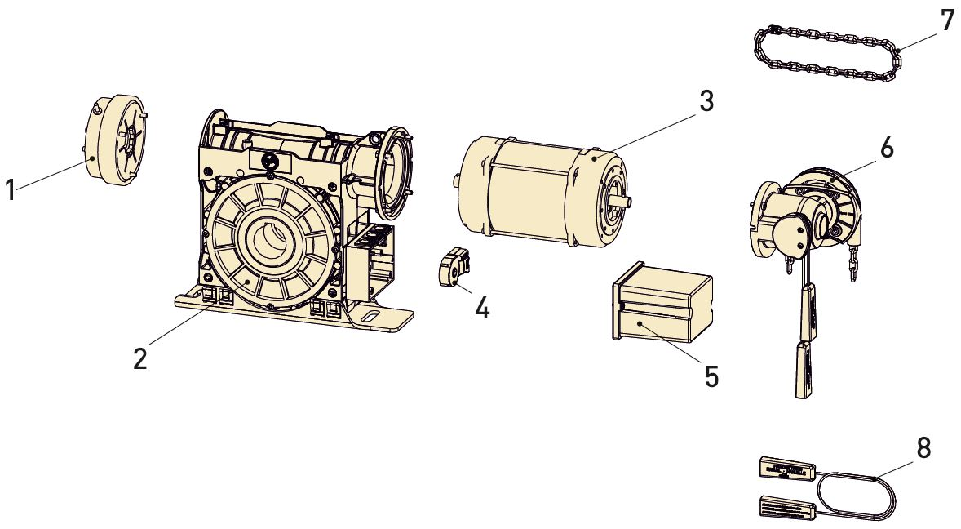

Figure .. Exploded Diagram of Operator

|  |  |
| --- | --- |
| **Operator** | |
| **Item#** | **Description** |
| 1 | Brake |
| 2 | Gearbox |
| 2 | Floating Foot |
| 3 | Motor 230V |
| 3 | Motor 460V |
| 4 | DES Encoder(Limit) |
| 5 | Limit Cover |
| 6 | Chain Hoist |
| 7 | Chain (8 Meter) |
| 8 | Ext.Cord (10 Meter) |

Table .1. Operator Bill of Materials

## APEX Pro Parts List

|  |  |  |  |
| --- | --- | --- | --- |
| **Part Type** | **Part #** | **DWG #** | **Description** |
| Motor and VFD Assembly | * | MA0263  MA0264  MA0265  MA0266 | Refer to original job sheet to identify the motor IM#, VFD assembly IM#, VFD mounting plate assembly IM#. |
| VFD Power Cable  Assembly | 201978 | EC0022 | Used for connecting the VFD junction box input power, including power cable, fitting, elbow fitting and conduit. |
| GFA Motor Parts | 523972a | * | SOLENOID BRAKE, GFA, 9 Nm |
| 522589a | * | SOLENOID BRAKE, GFA, 11 Nm |
| 523100a | * | SOLENOID BRAKE, GFA, 20 Nm |
| 523995a | * | SCREW, OIL VENTING PLUG, GFA |
| 524933 | * | ENCODER DES4, GFA, rectangular shape |
| Controller PCB and Module | 201948 | EP0131 | APEX PRO LOW VOLTAGE CONTROL PANEL |
| 201970 | EP0149 | APEX PRO, STANDARD MODULE |
| 201969 | EP0148 | APEX PRO, MULTI-IO MODULE |
| 201966 | EP0145 | APEX PRO, COMMUNICATION MODULE |
| 201967 | EP0146 | APEX PRO, HIGH POWER MODULE |
| 201968 | EP0147 | APEX PRO, LOCK DRIVE MODULE |
| Power Supply | 523896 | EP0060 | TRANSFORMER, JEFFERSON 7.5KVA |
| Cable And Connector | 201936 | EC0037 | APEX PRO SENSOR CABLE CONTROL SIDE, 6PIN |
| 201937 | EC0038 | APEX PRO SENSOR CABLE HUB, 4 CONNECTOR |
| 201938 | EC0027 | APEX PRO Y CONNECTOR, 49FT |
| 201982b | EC0036 | CBL,APEX PRO,ASSY,SENSOR |
| 201939 | EC0039 | APEX PRO DOOR EXTENSION CABLE, 4PIN,12ft |
| 201940 | EC0039 | APEX PRO CONTROL EXTENSION CABLE, 6PIN,12ft |
| 201941 | EC0040 | APEX PRO SENSOR CABLE HUB, 4 CONNECTOR, WHITE OPEN |
| 201942 | EC0035 | APEX PRO COMM CABLE, CONTROL SIDE, 5PIN，9FT Male |
| 201944 | EC0039 | APEX PRO COMM EXTENSION CABLE, 5PIN,12FT |

## Cabling Parts, Sensors, Junction Boxes

### Serial Numbers

Please reference the unit serial number when ordering parts as it will allow us to reference revisions and manufacturing dates to ensure that replacement equipment is compatible with your product

### Substitute Parts

The use of replacement parts not provided by the door manufacturer is not authorized and could void the product warranty.

## Warranty and Returned Parts Policy

### Warranty Parts

**Domestic Shipments:** Product is guaranteed to be free from defects in workmanship and materials for a period of 2 years from the date of factory shipment. This warranty includes replacement of parts, shipped via ground service to a job site or Customer’s warehouse. Warranty parts should be ordered in the method described in the beginning of this section of the owner’s manual. If parts are to be returned, CornellCookson will issue a return authorization containing a reference number, shipping address and other pertinent instructions for the parts to be returned within 30 days freight collect via one of the carriers listed in the return authorization information. Care should be taken to package returned part adequately to reasonably expect the parts to arrive undamaged from the return freight. Incomplete parts, or parts damaged due to inadequate or non-existent packaging will not be considered for warranty claims

The Customer agrees to pay for warranty replacement parts and freight if such parts are not found to be defective.

Shipment of warranty parts shipped via overnight or air freight will be at the customer’s expense and will be shipped freight collect. This warranty does not cover incidental costs such as guard service, liquidated damages, punitive damages, cost of removing or repairing adjacent or attaching structures, etc.

**Export Shipments:** Product is guaranteed to be free from defects in workmanship and materials for a period of 1 year from the date of factory shipment. This warranty includes replacement of parts, shipped via ground service to the U.S. Port of Exportation. Warranty parts should be ordered in the method described in the beginning of this section of the owner’s manual.

Shipment of warranty parts shipped via overnight or air freight will be at the customer’s expense and will be shipped freight collect. This warranty does not cover incidental costs such as guard service, liquidated damages, punitive damages, cost of removing or repairing adjacent or attaching structures, etc

**Electrical Warranty Conditions and Exceptions:** Incoming line voltages are required to fall within ranges established by ANSI C84.1 (ANSI Standard for Electrical Power Systems and Equipment) and wiring must be connected in accordance with applicable standards established by the current edition of NFPA-70 (NEC) for commercial rolling door operators. Unauthorized modifications or damage as a result of improper wiring or line voltage fluctuations will void all electrical warranties.

1.